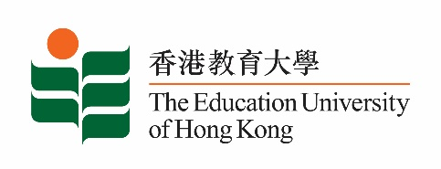

**致：**  **传媒机构采访主任**  25 September 2024

**To : News Editors**

**香港教育大学2024年 9 月 25至 10月6日可供采访之活动一览**

**The Education University of Hong Kong (EdUHK) Events Calendar for 25 Sep - 6 Oct 2024**

本校诚邀　贵机构派员采访下列活动。传媒查询，请联络教大传讯处（电话：2948 6050）。  
You are cordially invited to cover the events below. For media enquiries, please contact the Communications Office at 2948 6050.

以下活动或有人数限制，传媒请预先向主办部门登记。

There may be restrictions on the number of participants for the following event(s). Please contact the respective organiser(s) / department(s) for prior registration.

* **教大大埔校园** （新界大埔露屏路十号） / **EdUHK Tai Po Campus** (10 Lo Ping Road, Tai Po, New Territories)

|  |  |  |  |  |  |
| --- | --- | --- | --- | --- | --- |
| **日期**  **Date** | **时间**  **Time** | **活动**  **Event** | **地点**  **Venue** | **主办部门及公众查询**  **Organiser &**  **Public Enquiry** | **备注**  **Remarks** |
| 2024-10-04 | 9 am - 5 pm | **STEAM运动会**  **STEAMlympics** | 教大大埔校园  E座张海源室内运动场  Block E H.Y.Cheung Indoor Sports Hall  EdUHK Tai Po Campus | **主办部门 / Organiser:**  **Department of Health and Physical Education**  **健康与体育学系**  **查询 / Enquiries:**  **Dr. WONG Hoi Wai Henry**  **Tel / 电话: 2948 7094** | STEAMlympics为「智胜运动竞技场」计划的总结。希望透过比赛，促进校内在体育活动中融合科学、科技、工程、艺术和数学的元素。  免费入场，  欢迎各界人士参加。Free admission.  All are welcome. |